

**Course Code: SE 231**

**Course Title: System Analysis & Design Project**

**Submitted To**

# Name:  Khalid Been Md. Badruzzaman Biplob

# Designation: Lecturer .

**Daffodil International University**

**Submitted By**

**Name: Md.Traqul Islam Tareq**

**ID: 192-35-2890**

**Submit date:29-04-2024**

# Sequence diagram for

1. Login
2. User registration
3. Browsing product
4. Shopping cart
5. Search and filter
6. Product management
7. Order placement
8. Payment intrigation
9. Product review and rating
10. Order cancelation
11. Delivary tracking

1. Login

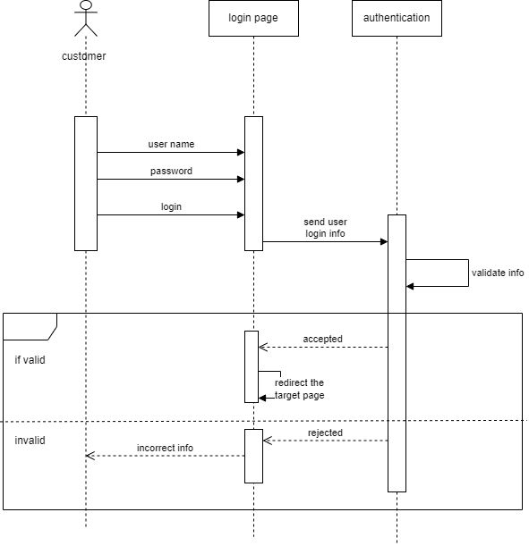

2.User registration

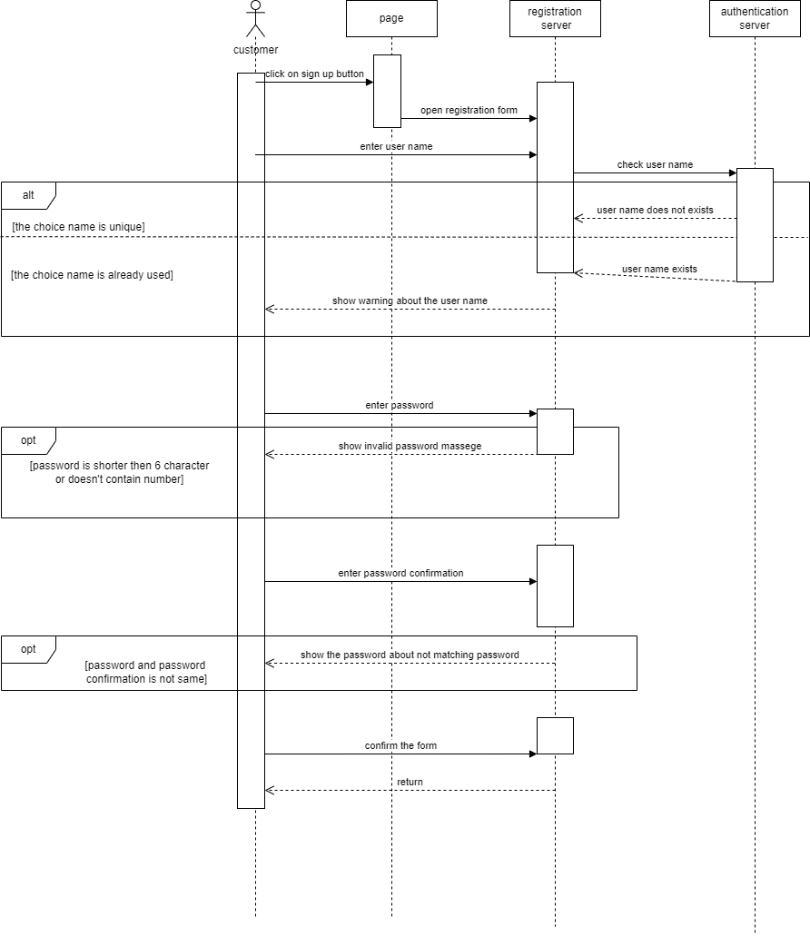

3.Browsing product

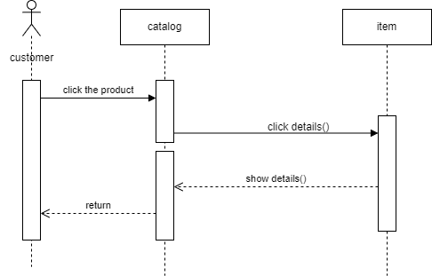

4.Shopping cart

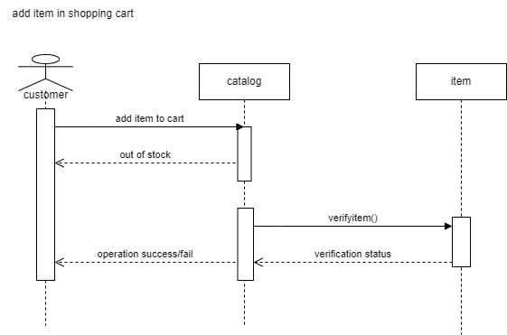

5.Search and filter

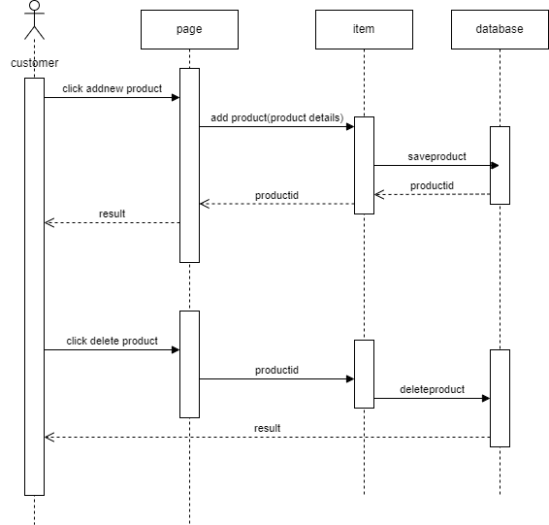

6.Product management

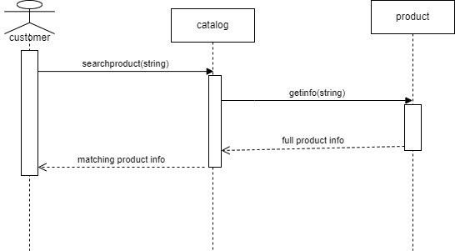

7.Order placement

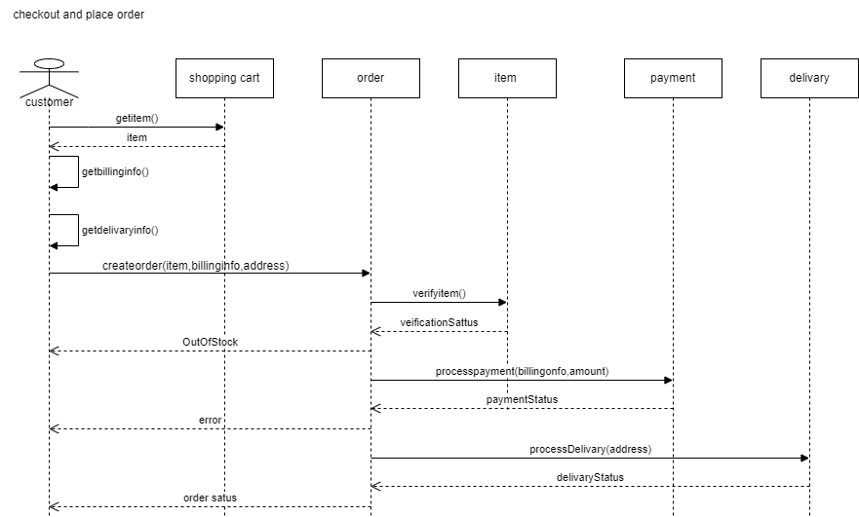

8.Payment intrigation

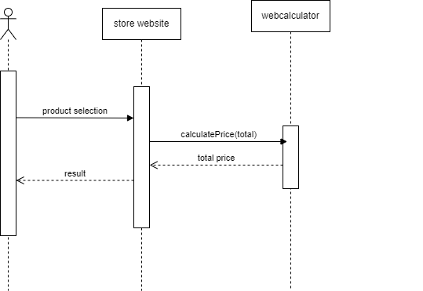

9.Product review and rating

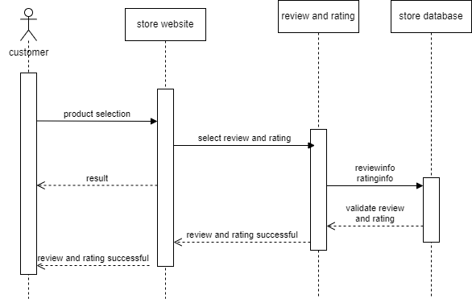

10.Order cancelation

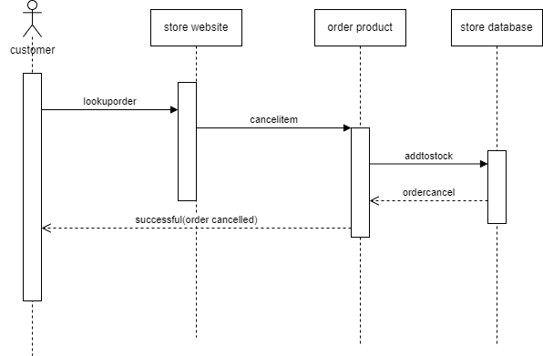

11.Delivary tracking

